ODS – Operational Data Store.

Replicate Dataverse data to Azure SQL Database.

**Contributors**

Chetan Hiran

Sathishkumar Ramamurthy

Amrita Ahirrao

Dakota Giltner

**Date**

April 2023

**Version**

1.0

Table of Contents

Overview 2

Prerequisites 3

Architecture 4

Best Practices when using ODS framework. 7

Deployment Steps 8

Create Data Factory 8

Import the Pipelines through ARM Template 8

Post deployment validation 10

Pipeline Details and Execution Sequence: 11

01 - Master Data Load 11

02 - Entity Schema Sync Master 12

03 – Data Sync Master: 13

Known Issues 14

# Overview

ODS is a framework developed to replicate data from Microsoft Dataverse to an Azure SQL Database in a user owned Azure Subscription. This framework will replicate data similar to [Data Export Services](https://learn.microsoft.com/en-us/power-platform/admin/replicate-data-microsoft-azure-sql-database). Since [Data Export Services](https://learn.microsoft.com/en-us/power-platform/admin/replicate-data-microsoft-azure-sql-database) got retired and got replaced with [Azure Synapse Link for Dataverse](https://learn.microsoft.com/en-us/power-apps/maker/data-platform/export-to-data-lake). Currently there is no support to export the Dataverse data directly to Azure SQL Server close to real time, as Azure Synapse link has the latency of ~15 mins or more. This ODS framework will solve this problem in a cost-effective way and eliminates the dependency on Synapse.

ODS supports Azure SQL Database, but the framework can be easily extended to support SQL Server on Azure virtual machines or on-Premises SQL server. The ODS intelligently synchronizes the full Dataverse data initially and thereafter synchronizes on a continuous basis as changes occur (delta changes) in the system.

**How does ODS sync the Data from Dataverse:**

ODS uses the change tracking flag in Dataverse to synchronize data with external systems, refer to the link [Use change tracking to synchronize data with external systems (Microsoft Dataverse) - Power Apps | Microsoft Learn](https://learn.microsoft.com/en-us/power-apps/developer/data-platform/use-change-tracking-synchronize-data-external-systems) to learn about the change tracking and delta token.

# Prerequisites

1. Azure SQL database:

A Azure SQL database and an account with the below permissions.

| **Permission type** | **Permission name** |
| --- | --- |
| CRTB | CREATE TABLE |
| CRTY | CREATE TYPE |
| CRVW | CREATE VIEW |
| CRPR | CREATE PROCEDURE |

Schema permissions required.

| **Permission type code** | **Permission name** |
| --- | --- |
| AL | ALTER |
| IN | INSERT |
| DL | DELETE |
| SL | SELECT |
| UP | UPDATE |
| EX | EXECUTE |
| RF | REFERENCES |

1. **Azure Data Factory:**

Follow the steps to create the data factory.

<https://learn.microsoft.com/en-us/azure/data-factory/quickstart-create-data-factory>

1. **Azure Key Vault service**

Create an Azure Key Vault and provideSecrets User Role for Data Factory.

1. **Azure Blob Storage**

Create Azure Blob Storage and provide Data Contributor role for Data factory. The ADF pipeline execution logs can be found in this storage.

1. Microsoft Dataverse

In D365 provision an Application user with System Administrator security role and we will use this Application user context to call the OData API in Pipelines.

# Architecture



1. Pipeline Design:
   1. Schema Sync Pipeline



* 1. Data Sync Pipeline



## Best Practices when using ODS framework.

* To avoid synchronization errors due to resource throttling, we recommend that you have an Azure SQL Database Premium P1 or better plan
* Enable Change tracking on Dataverse Entities. More Information: [Enable Change Tracking in Power Platform.](https://learn.microsoft.com/en-us/power-platform/admin/enable-change-tracking-control-data-synchronization)
* Periodically update database statistics on tables and indexed views in the SQL database. More information: [Update Statistics](https://learn.microsoft.com/en-us/sql/relational-databases/statistics/update-statistics?view=sql-server-ver16)
* Monitor the SQL database's utilization. More information: [Perf monitoring](https://learn.microsoft.com/en-us/azure/azure-sql/database/monitor-tune-overview?view=azuresql)
* Monitor Data Factory Pipeline execution. More Information: [Monitor using Azure Monitor](https://learn.microsoft.com/en-us/azure/data-factory/monitor-using-azure-monitor)

# Deployment Steps

## Create Data Factory

Follow the steps to create the data factory.

<https://learn.microsoft.com/en-us/azure/data-factory/quickstart-create-data-factory>

## Import the Pipelines through ARM Template

1. Navigate to Manage -> ARM Template -> Import ARM Template.

1. Select “Build your own template in the editor.”

1. Browse to “ARMTemplateForFactory.json” file.

1. Click Save
2. Enter the configuration details.

1. Click Review + Create.

This will deploy the pipeline to the Data factory.

## Post deployment validation

1. Open Data Factory Studio
2. Navigate to Manage -> Linked Services and Test all the connections.

1. Test all the connections.

# Pipeline Details and Execution Sequence:

## 01 - Master Data Load

This is used to onboard all the D365 entities in SQL database. This pipeline will create a new record for each D365 entity in [ODS].[EntitySync] table.

The table [ODS].[EntitySync] has three important columns below

1. “SyncReady”: The Data load will happen only for the Entities which has SyncReady = 1. This flag is used in the pipeline “03 - Data Sync Master”
   1. How to set the SyncReady to 1.

UPDATE ODS.EntitySync

SET SyncReady = 1

WHERE EntityName = 'account'

1. “SyncFrequency”: This column is used in the pipeline “03 - Data Sync Master” for filtering purpose.
2. DeltaToken: When this value is NULL, it means the entity is loaded for the first time and if it has value then the Data load will be performed based on the Delta Token. So any time if you wanted to perform full data load for the entity, then set the value as NULL for entity in the table.
   1. How to set the DeltaToken to NULL.

UPDATE ODS.EntitySync

SET DeltaToken = NULL

WHERE EntityName = 'account'

**Note:**

* Execute this pipeline manually once you complete the setup of the pipelines.
* After first time execution, Any time when you have a brand new entity in D365 and if you wanted to perform Data Sync for the entity then execute this pipeline.

**PARAMETERS**: This pipeline has no parameters.

**How to Execute the Pipeline:**

1. Navigate to Author -> 01 Master Data Load -> Add Trigger -> Trigger Now
2. The pipeline will load data on ODS.EntitySync table.
3. Update SyncReady Flag in ODS.EntitySync table using the below sample script. Update this flag for only the entities for which you wanted to sync the data from Dataverse.

UPDATE ODS.EntitySync

SET SyncReady = 1

where EntityName = 'account'

**Note:** Only the entities flagged as SyncReady = 1 will be set for data sync.

## 02 - Entity Schema Sync Master

This pipeline creates the actual physical table in the database for the entities that are marked as SyncReady = 1 in the table [ODS].[EntitySync] and inserts entity attribute details into [ODS].[EntityAttributeSchema] table. There will be two tables created for each entity, one with the ODS and other with STAGING schema. Execute this pipeline manually after each solution deployment to environment. This pipeline helps to sync the schema between D365 and the SQL database.

**Note:**

* Execute this pipeline manually once you complete the execution of the pipeline “01 - Master Data Load” setup of the pipelines.
* Execute this pipeline manually after each solution deployment to environment to have the entity schema be in sync between D365 and SQL Database. Basically if you are making any schema changes in the existing entity or adding any new entity in D365 and if you want those schema changes/new entity to get reflected in the Database then you should execute this pipeline.

**PARAMETERS**:

|  |  |  |  |
| --- | --- | --- | --- |
| Parameter Name | Data Type | Default Value | How to Use |
| EntityName | String | {“key”: “all”} | If you want to run the pipeline for a specific entity, replace the word all with the table name in the comma separated format. For example: {“key” : “account, contact”}  If set to “all” it will pick up all entities for which SyncReady = 1 is set in the table [ODS].[EntitySync]. |

**How to Execute the Pipeline:**

1. Navigate to “02 – Entity Schema Sync Master” -> Add Trigger -> Trigger Now and mention the parameter value.

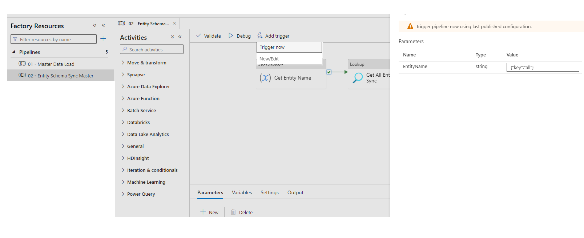

## 03 – Data Sync Master:

This pipeline will sync the data from D365 to Azure SQL db. It is recommended to create triggers to sync the data at periodic intervals. This way your data will be synced at regular intervals.

You can also run this pipeline only for selected entities by passing the entity name as parameter.

**PARAMETERS**:

|  |  |  |  |
| --- | --- | --- | --- |
| Parameter Name | Data Type | Default Value | How to Use |
| SyncFrequency | String | Daily | Corresponds to the value in the SyncFrequency column in the ODS.EntitySync table. This must match any entity that you want to sync with this pipeline. |
| EntityName | String | {“key”: “all”} | Specifies the entity to sync. If you want to run the pipeline for a specific entity, replace the parameter value to “all” with the table name in the comma separated format. Example: {“key”: “account, contact”}  If set to “all” it will pick up all entities that match the SyncFrequency parameter, which refers to the column SyncFrequency in the table ODS.EntitySync. |

**How to Execute the Pipeline:**

1. Navigate to Author -> 03 – Data Sync Master -> Add Trigger -> Trigger Now

04 - Data Sync – OptionSets

This pipeline creates the actual physical table in the database for OptionSetMetadata and GlobalOptionSetMetadata with ODS and STAGING Schema and sync the data from D365 to SQL to the respective tables. You can place the trigger as needed for this pipeline.

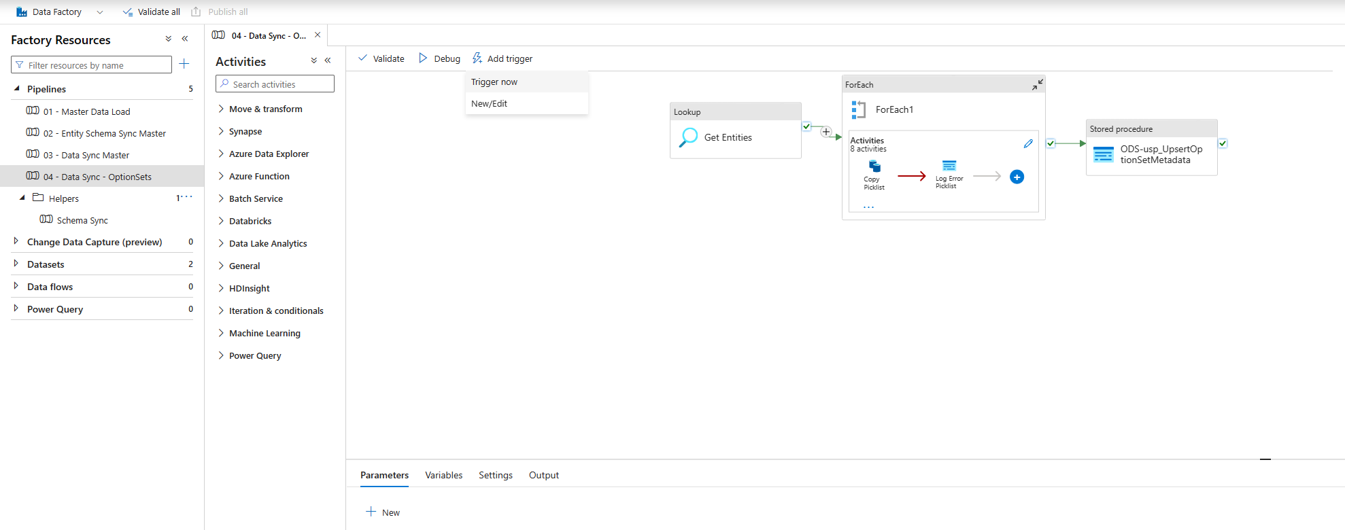

**How to Execute the Pipeline:**

Navigate to Author -> 04 - Data Sync – OptionSets -> Add Trigger -> Trigger Now

# Known Issues

There are no known bugs when using the framework at this point.